C:\Users\William\AppData\Local\Microsoft\Windows\Temporary Internet Files\Content.IE5\T4T0THGR\MC900150054[1].wmf

Paul Revere was born on **January 1, 1735**.

May 10, 1818

The United States declared independence from England on **July 4, 1776**.

1775

July 4, 1776

Timeline of **Paul Revere’s** Life

Paul Revere died on **May 10, 1818**.

Paul Revere became a silversmith in **1748**.

In **1775**, Paul Revere warned the American people that the British were going to attack.

1748

Glue next page here.

Glue next page here.

Glue next page here.

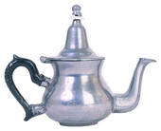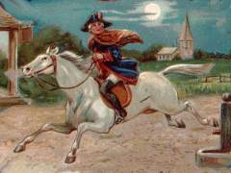C:\Users\William\AppData\Local\Microsoft\Windows\Temporary Internet Files\Content.IE5\YY1DNRXP\MC900216576[1].wmf

January 1, 1735